ENGLISH FIRST ADDITIONAL LANGUAGE
GRADE 10 - PAPER 3
NOVEMBER 2013
TOTAL: 100
TIME: 2½ Hours

INSTRUCTIONS AND INFORMATION
1. This paper consists out of three sections:
SECTION A: Essay 50
SECTION B: Transactional Writing 30
SECTION C: Shorter Piece 20
2. Answer ONE question from each section.
3. Begin the answer of each section on a new page.
4. Include your planning for each section.
5. When you hand in, make sure you have drawn a line through your planning.
6. Place your rough work behind the neat work.
7. Staple your answers to the front of your question paper.
8. Write EXTREMELY neatly!
9. Write down the number of the question you decide to do.

SECTION A – ESSAY
QUESTION 1
Write an essay of 150-200 words in length (about 1 page) on ONE of the following topics.
Write down the number and title of your essay correctly, for example 1.1 The Dream
Give your own title if your choice is QUESTION 1.4.1 OR QUESTION 1.4.2
Spend approximately 60 minutes on this section.

1.1 The Dream
Write a descriptive essay about a dream you have had. It can be a pleasant dream or a nightmare – as long as it is interesting!
[50]
1.2 Argumentative Essay
Choose one of the topics for the Argumentative essay if you choose to do this question.
1.2.1 Children should be given pocket money to spend at school.
1.2.2 Corporal punishment should be re-introduced at schools. Note: Corporal punishment means physical punishment, e.g. beating or caning.
1.2.3 Learners should wear a uniform to school
1.2.4 Learners should be allowed to wear make-up to school
[50]
1.3 Write a funny story
Write a funny story. When people tell funny stories they usually have:
- Characters
- A setting
- A problem or conflict
- A climax
- An ending

Choose your own heading for your funny story.
[50]
1.4 Choose one of the photographs and write an essay on a topic that comes to mind. Write the question number and give your essay a suitable title.

1.4.1 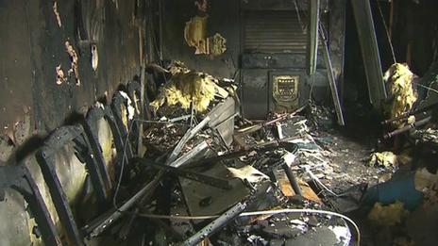

1.4.2 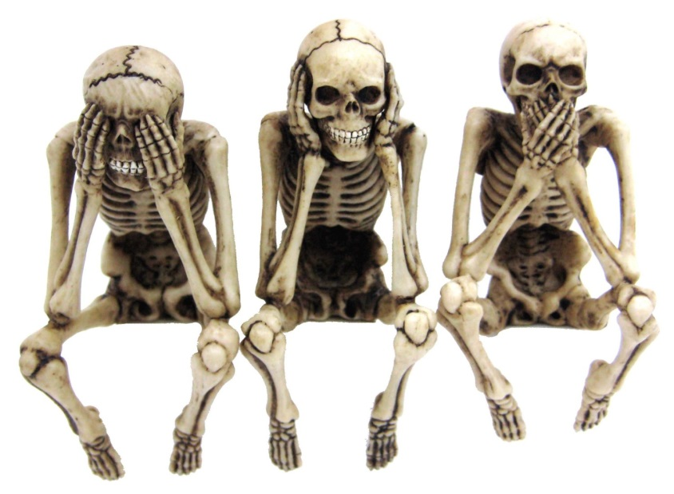
[50]

SECTION B – TRANSACTIONAL WRITING
QUESTION 2
Respond to ONE of the following transactional writing tasks.
The body of your response should be 120-150 words in length (about 12-15 lines.)
Write down the number and the heading of the text you have chosen to write.
Pay particular attention to format, language, register and audience.
Spend approximately 40 minutes on this section.

2.1 Friendly letter (Choose 2.1.1 or 2.1.2)
2.1.1 A friend from another province is coming to visit you for a week. Write a letter to him/her telling him/her about your plans for the visit. Do not forget to use the correct format of a friendly letter.
2.1.2 Write a letter to a family member thanking them for a gift you received recently.
[30]
2.2 Letter to the Press
Write a letter to the press about something that the greater community is interested in. It can be in response to an article in the newspaper, or a response to another letter, or even just something you feel strongly about.
[30]
2.3 Writing a paragraph.
Write an argument to support one of the following topics
- Contact sports like rugby and boxing are not suitable for women.
- Every scholar should take part in sports.
[30]
2.4 Write a business letter
Write a letter of complaint. Write a letter to the principal of your school to complain about one of the following issues:
- The lack of sports facilities for female learners
- The poor condition of the toilets at school
- The shortage of books in the school library
- Sexual harassment of female learners at school
[30]
2.5 Formal Speech
Write a formal speech.
Your speech title is: “Why electronic communication is a good thing”.
[30]

SECTION C – SHORTER PIECE
QUESTION 3
Choose ONE of the following topics and write a short text.
The body of your response should be 80-100 words in length (about 5-8 lines).
Write the number and the heading of the text you have chosen.
Spend approximately 20 minutes on this section

3.1 Diary entries
You recently experienced certain problems at home or at school. Write down diary entries for any three days during this period. Start each entry with the date.
[20]
3.2 Poem
Write a poem on being a teenager today. Your poem may take any form.
[20]
3.3 Write an informal E-mail

Hi Mashadu and Mick
How are you both? Well, I hope. It’s only been a week since term ended, and I am bored back here Tshipise without you guys.
Great news – I have a holiday job! My Ma got me the job helping in Reception at the hotel, and I am earning R20 per hour. So, I have money to spend and on Monday I want to go in to Makhado when my parents go for business.
Please can we meet up? It would be great to practise some cricket at the school nets with you guys, then get a burger for lunch and see a movie in the afternoon.
Please let me know if you can make it and what you think of this plan.

Your friend
Taks Cell: 083 586 799

Write a short email reply from Mashudu. Use the form provided.
[20]

3.4 Giving directions
Give directions from block 234 to security checkpoint 1. Use the diagram.
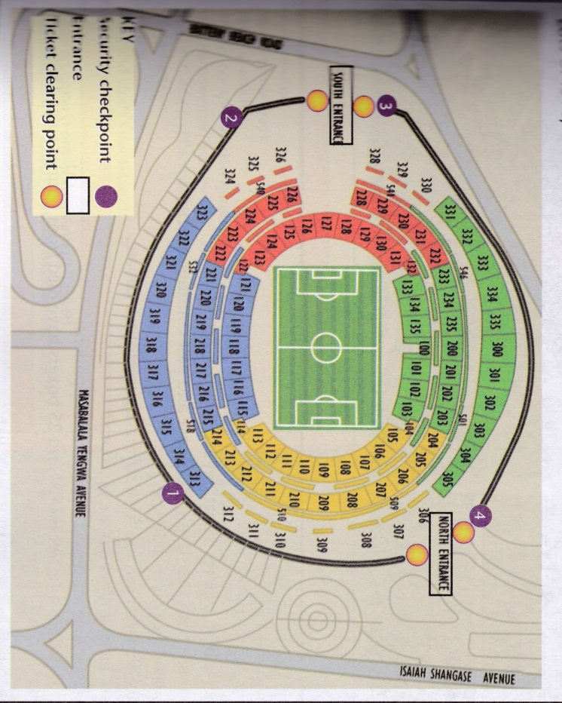
[20]
3.5 Writing a paragraph
Write a descriptive paragraph for your school magazine on “A great goal/try”.

[20]
See question on the next page as well
3.6 Filling in a form (If you do this form, detach it and staple it to your answers.)

Application Form
AMERICAN STUDY PROGRAMME
X Please read every section of the form carefully before filling in any information.
X Please fill out the questionnaire in black ink.
X Do not use abbreviations
SECTION A: Personal Details
Dr | Prof | Mr | Mrs | Miss | Ms
1. Names (as they appear in your passport/ID)
First: |  | Middle: |  | Surname:
2. Telephone numbers:
School: |  |  | Home:
Cell: |  | Fax: |  | Email:
3. School address: |  |  | Home address:
4. Date of birth: Day:____Month:____________ Year:__________
5. Country of citizenship:
6. Home Language:
7. Ability in English: Excellent [ ] Good [ ] Poor [ ]
SECTION B: Educational Qualifications
1. Highest grade passed:
2. School:
3. School subjects:
1. |  |  | 2.
3. |  |  | 4.
5. |  |  | 6.
7. |  |  | 8.
4. Other Skills: (e.g. computer skills such as keyboard, email, word processing and Internet use)
SECTION C: Needs/Interests Analysis
If you were given the opportunity to study in the US, how would you give back to your community / country of origin after you complete your studies?
SECTION D: References
Teacher/Principal: |  |  | Contact No.
Community Leader: |  |  | Contact No.
“I certify that all of the above factual information is correct and complete, and the ideas expressed are my own.”
My signature:
My name (print):
Today’s date:

[20]

